Business Intelligence BSIT 701
10/04/2026

Group 3
Student Number | Initials | Surname
22315958 | A.E | Zulu
21814236 | S.S | Ndlela
22334812 | A | Sosibo
21742106 | S.S | Shezi
22326212 | S.N | Jele
22256578 | S.P | Buthelezi
26091530 | S.G | Lunga
22228521 | S.M | Mthiyane
22258409 | N.A | Simamane
22227345 | M.S | Sithole

Tools: MS Excel – Power Query & MS Power BI

Contents
Task 1 – Data Import, Cleaning & Preparation 3
1.1 Data Import 3
1.2 Feature Engineering 8
Task 2 - Descriptive Statistical Analysis 8
2.1 Sales Performance KPIs 8
2.2 Sales Trend and Seasonality Analysis 8
2.3 Customer and Demographic Analysis 8
2.4 Digital Behavior and Device Analysis 9
2.5 Delivery Performance and Customer Satisfaction - Visual in the pbix ‘Digital behavior.’ 9
References 10

Task 1 – Data Import, Cleaning & Preparation

1.1 Data Import
1.1.1 After reviewing the data, we found that session_duration_minutes was a whole number, and we updated the data type to a decimal. The following screenshots reflect each column with its correct data type.
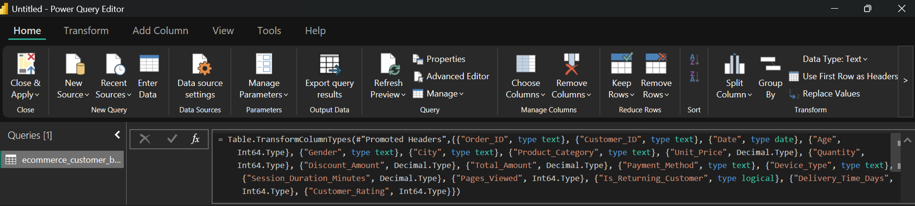

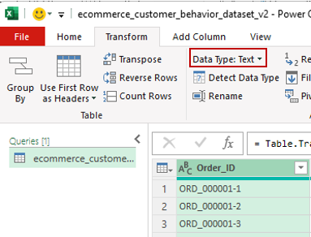
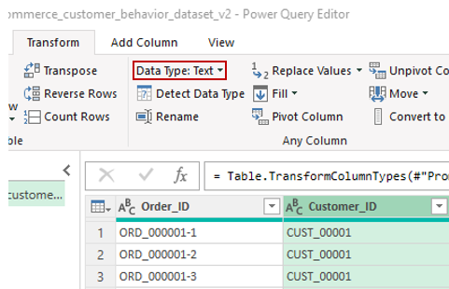

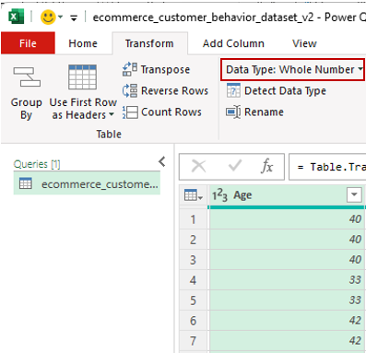
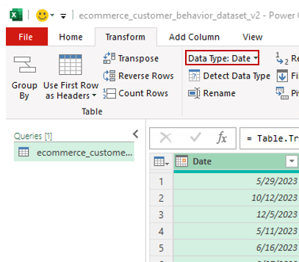

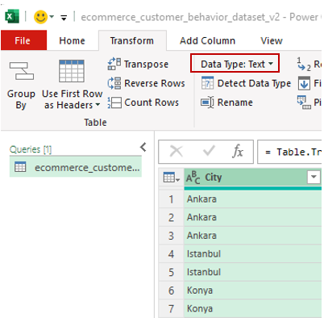
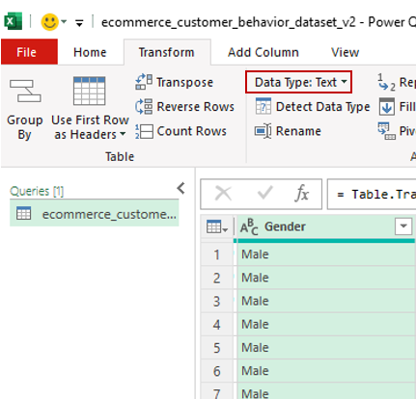

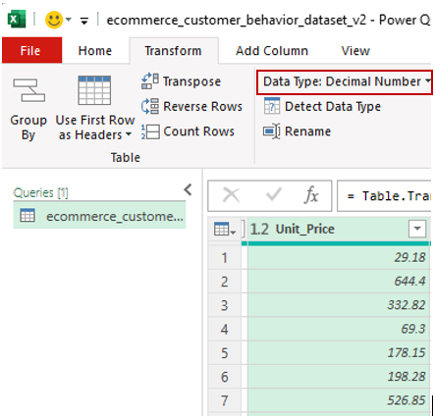
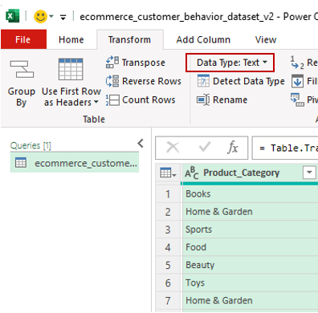

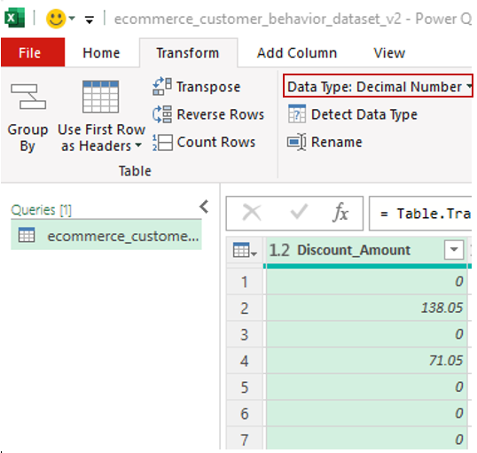
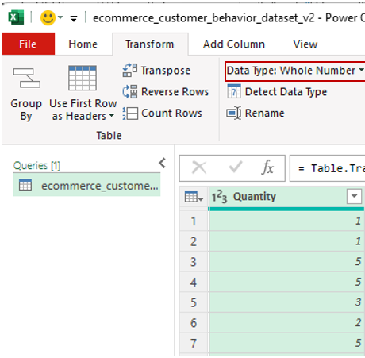
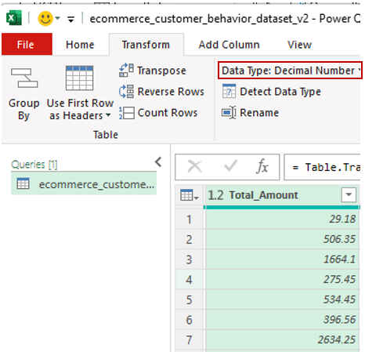
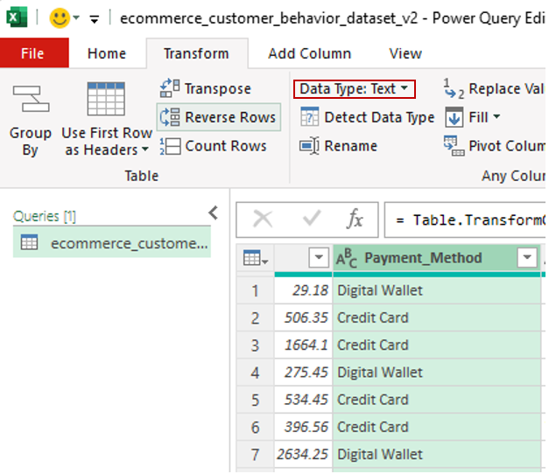

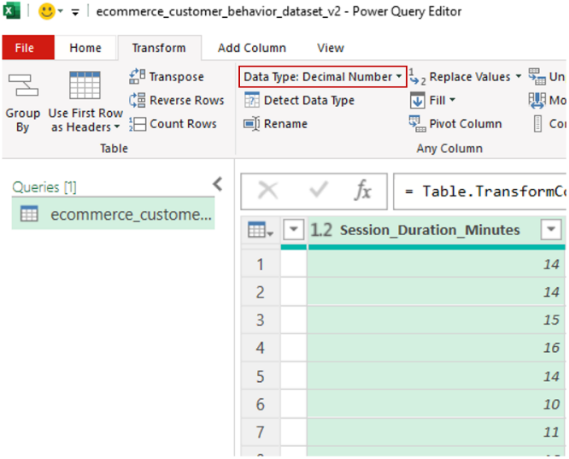
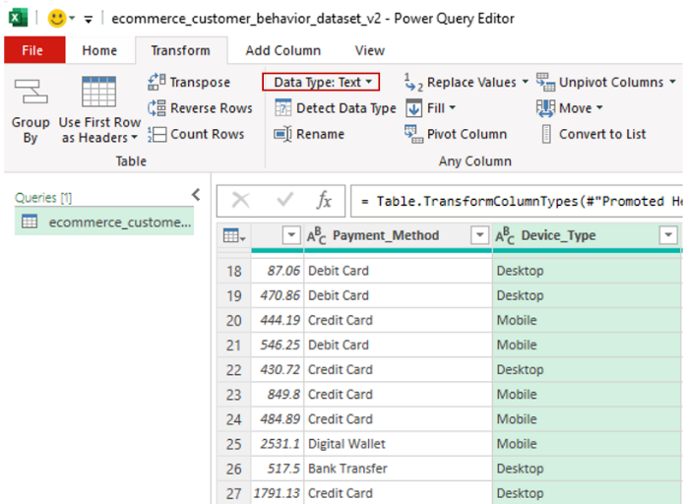

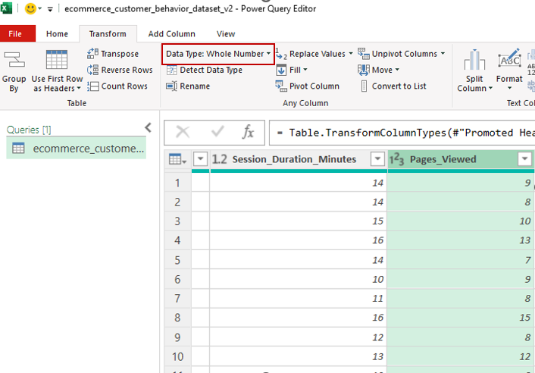
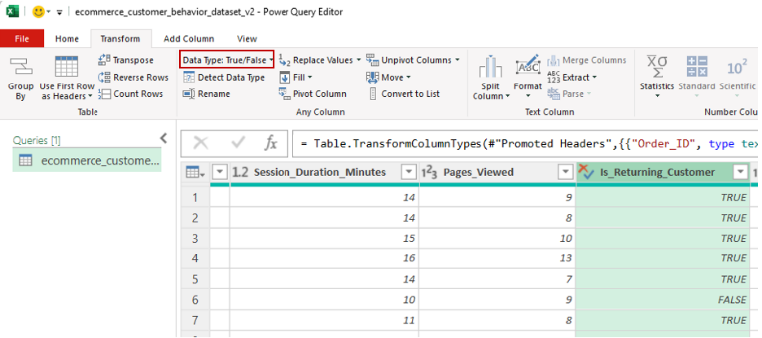

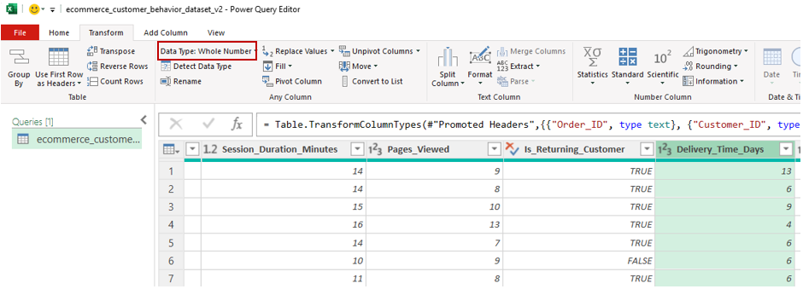

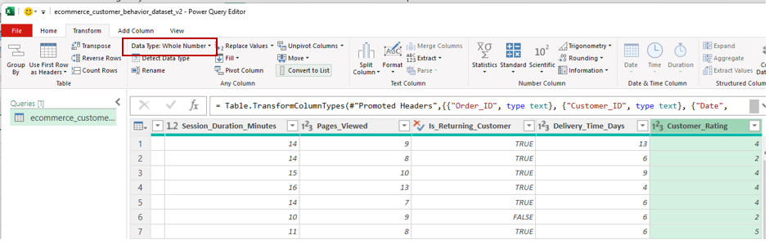

    - Upon conducting the Data Quality Audit, the following are my findings
- 0 Null Values (Kindly find the Excel workbook attached and refer to the Null_Count_Summary Tab)
- No Order_ID duplicates found across columns (Kindly find the Excel workbook attached and refer to )
- Yes, Data type correction was applied to session_duration_minutes.
- Kindly find the excel workbook and refer to the tab: Oulier_Summary
- Since we did not have any null values nor did we have any duplicate values, no action was taken.

    - After a successful power query validation check using the formula: Total_Amount ≈ (Unit_Price × Quantity) − Discount_Amount. Rows that had over 1 TRY difference were set to “check”, else set to “OK”. Refer to the Excel workbook, tab “ecommerce_customer_behavior_dat”, columns STU as per the screenshot below
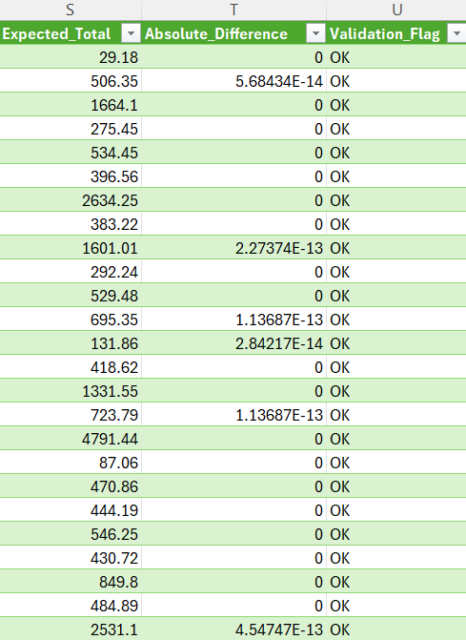

1.2 Feature Engineering
The columns required were created in Microsoft Power BI. Kindly find the attached MS Power BI File and refer to the tab “Dashboard”, table “ecommerce_customer_behavior_dat”

Task 2 - Descriptive Statistical Analysis

2.1 Sales Performance KPIs
2.1.1 Kindly find the attached MS Power BI File and refer to the tab “Sales KPIs & Trend Analysis” to see visuals for KPIs
2.1.2 Business Significance
- Total Revenue: Reflects business success or failure by clearly showing overall performance through sales.
- Total Orders: Reflect the number of orders that the business acquired over a period of time. This helps the business to track which products are in demand and which ones are not.
- Average Order Value: Helps assess how much customers spend per order, so the business can observe revenue efficiency.
- Average Customer Rating: Helps with Customer Relationship Management (CRM) by giving an insight into how satisfied customers are with the product or service.
- Average Delivery Time: This gives a great insight into the company’s logistics and supply chain operation, allowing for proactivity towards decision-making.
- Discount Penetration Rate: Reflects the effect of the discounted product on the overall sales and brand visibility.
- New vs Returning Split: Provide insight on how many customers have been acquired, reflecting effective marketing strategies, and also how many clients have been loyal reflective effective customer relationship management.
- Top Product Category and Top City by Total amount: Drives focus on the right product in the right cities in order to gain and maintain more sales through identifying the perfect target market.

2.2 Sales Trend and Seasonality Analysis
2.2.1 Kindly find the attached MS Power BI File and refer to the tab “Sales KPIs & Trend Analysis” to see visuals for Sales Trend and Seasonality Analysis.

2.3 Customer and Demographic Analysis
2.3.1 Kindly refer to the pbix. file tab Customer and Demographics
2.3.2 Kindly refer to the pbix. file tab Customer and Demographics
2.3.3 Kindly refer to the pbix. file tab Customer and Demographics
2.3.4 RFM Segment Profile Table:
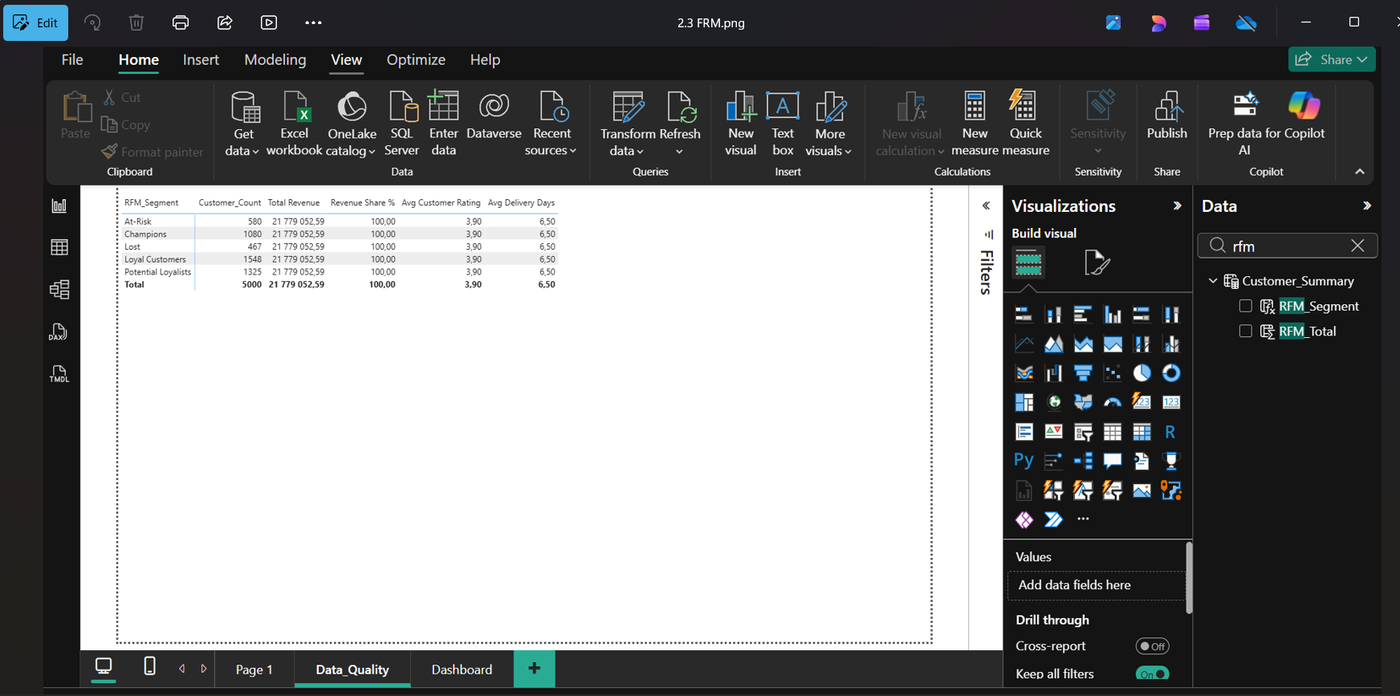

2.4 Digital Behavior and Device Analysis
2.4.1 Kindly refer to the pbix file, table Digital Behavior.
2.4.2 In any case, when a human being willingly spends more time with or in anything, it means they like/enjoy that thing. Longer sessions with more pages viewed will definitely lead to better satisfaction and subsequently better or more ratings. (Visual in the pbix ‘Digital behavior’).
2.4.3 Kindly refer to the pbix file, table Digital Behavior.
2.4.4 OAV is directly proportional to pages viewed (Visual in the pbix ‘Digital behavior’).

2.5 Delivery Performance and Customer Satisfaction - Visual in the pbix ‘Digital behavior.’
2.5.1 No, books have the fastest delivery and the highest rating.
2.5.2 Yes, Fast delivery lead to a high rating
2.5.3 Delivery is often slower for discounted products as it may lead to an unusually high number of orders. Discounts could also negatively impact customer satisfaction due to slower deliver and some customers may associate discounted products with lower value.
2.5.4 Customers who receive their orders in under 4 days are over 50% more likely to be loyal, and they are likely to rate their products higher than those who have to wait over 5 days for their products to be delivered. As things stand, the fastest delivery rate is below satisfactory statistically, which puts the company at a higher risk of retention.
The COO must look at the high-value/volume cities and implement a strategy or put a fast delivery system in place. This will help retain customers and gain new ones because, more than several things, consumers value time, and they would always prefer the fastest, most efficient solution.

References
https://aws.amazon.com/products/databases/?trk=9bd1b713-0faf-4080-a1d2-e58f439fd8e3&sc_channel=ps&ef_id=Cj0KCQjwv-LOBhCdARIsAM5hdKdT5UnoLovT_F2yeBGyf-JBv-LyUS_hgBafPnQmTBLGE1OQjSK0-7gaAi2bEALw_wcB:G:s&s_kwcid=AL!4422!3!798628545119!p!!g!!business%20intelligence%20dashboard!23600693937!192406577734&gad_campaignid=23600693937&gbraid=0AAAAADjHtp98ajcHE3bzl-IEED0-R7TdW&gclid=Cj0KCQjwv-LOBhCdARIsAM5hdKdT5UnoLovT_F2yeBGyf-JBv-LyUS_hgBafPnQmTBLGE1OQjSK0-7gaAi2bEALw_wcB

https://learn.microsoft.com/en-us/dax/new-dax-functions
https://www.youtube.com/watch?v=waG_JhBgUpM

